**46.2. Maven Overview - 2**

**Standard Directory Structure**:

* Normally when we join a new project
  + Each development team dreams up their own directory structure
  + Not ideal for new comers and not standardized
* Maven solves this problem by providing a standard directory structure

**Maven Directory Structure**:

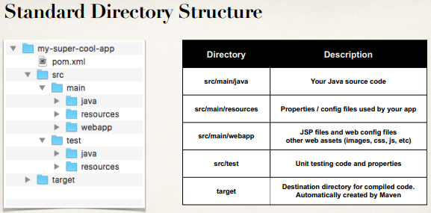

**Place Java source code – Maven project**:

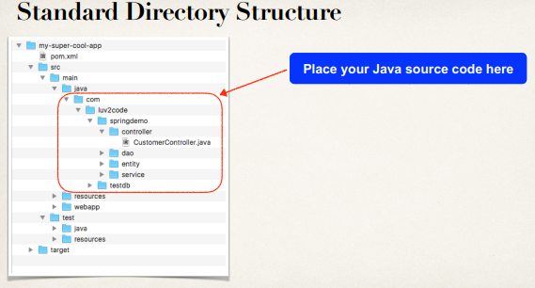

**Place Web assets Maven project**:

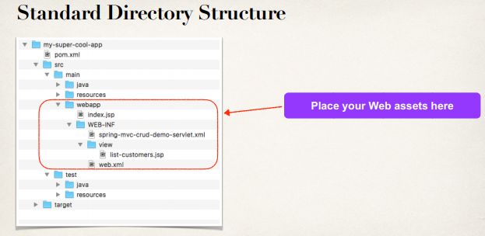

**Standard Directory Structure Benefits**:

* For new developers joining a project
  + They can easily find code, properties files, unit tests, web files etc.
* Most major IDEs have built-in support for Maven
  + Eclipse, IntelliJ, NetBeans etc.
  + IDEs can easily read/import Maven projects

* Maven projects are portable
  + Developers can easily share projects between IDEs
  + No need to fight about which IDE is the best!

**Advantages of Maven**:

* Dependency Management
  + Maven will find JAR files for us
  + No more missing JARs
* Building and Running our Project
  + No more build path / class-path issues
  + Standard directory structure

**Best Maven Benefit(s)**:

* Once we learn Maven, we can join a new project and be productive
* We can build and run a project with minimal local configuration